Virtual Machine creation

**Task 1: Creating a Windows Virtual Machine.**

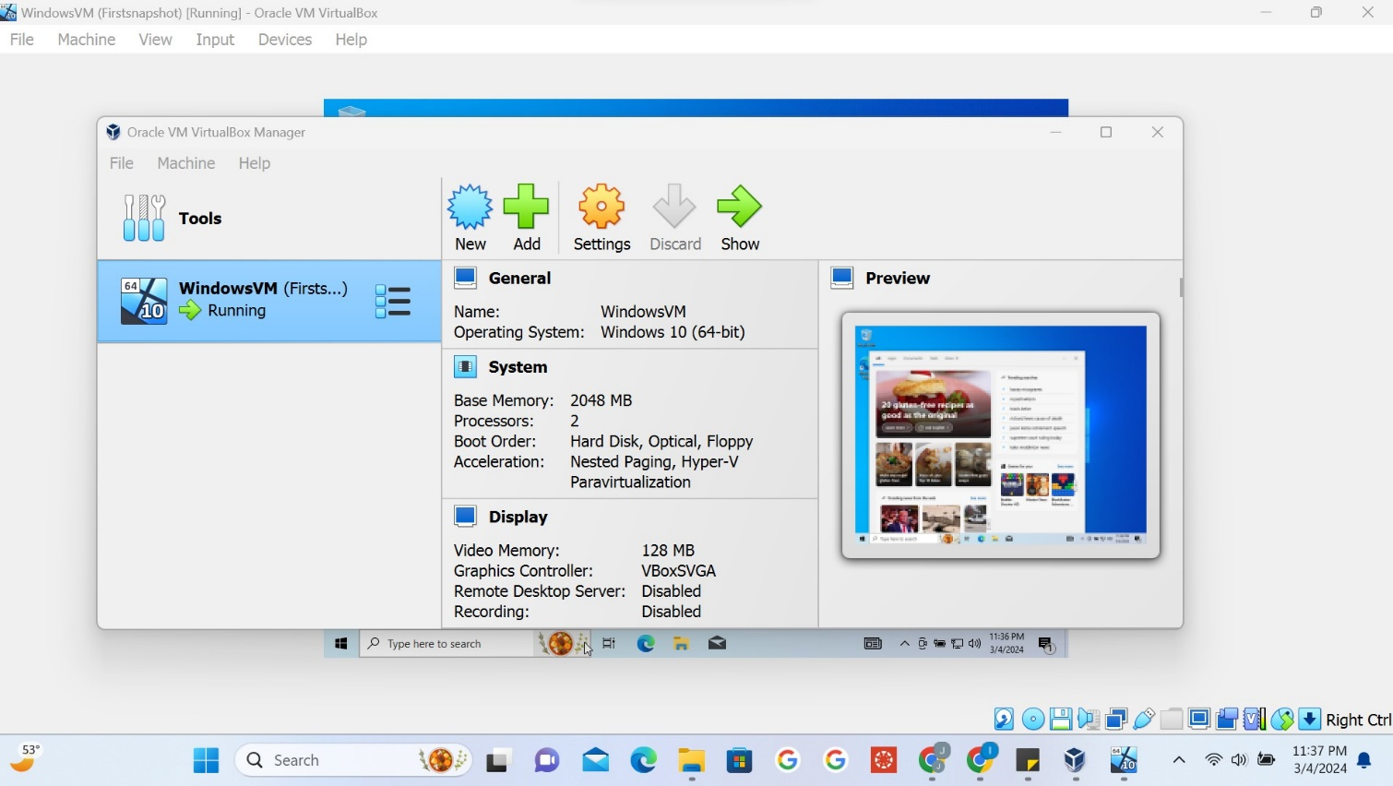

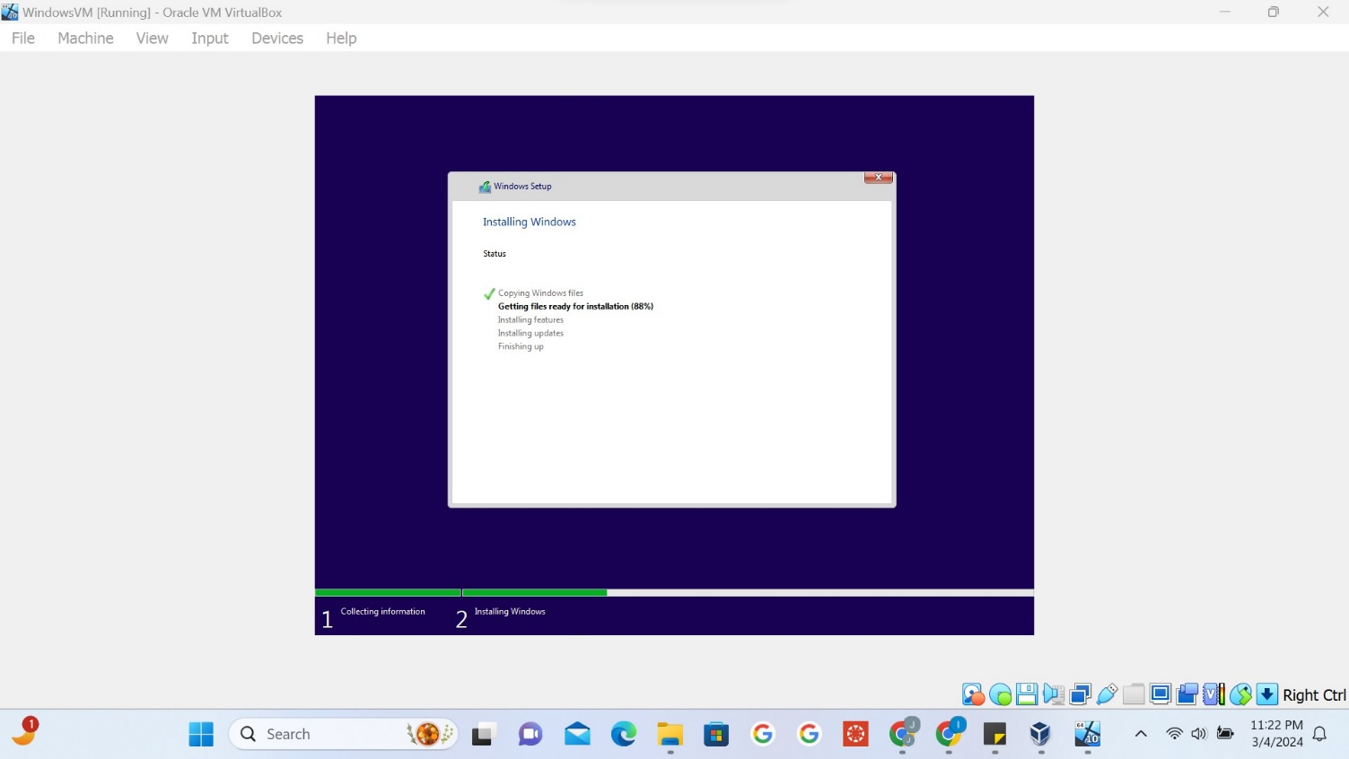

**Task 2: Initial Configuration**

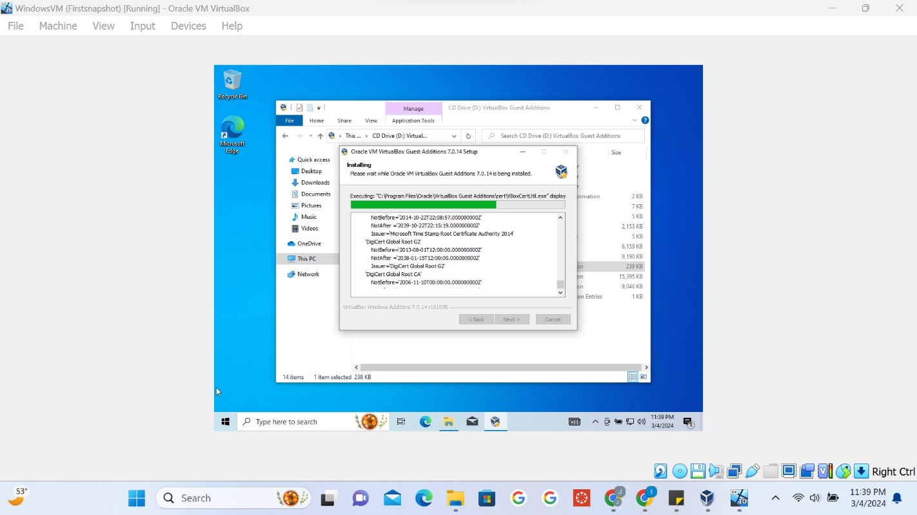

**Task 3: Taking a Snapshot**

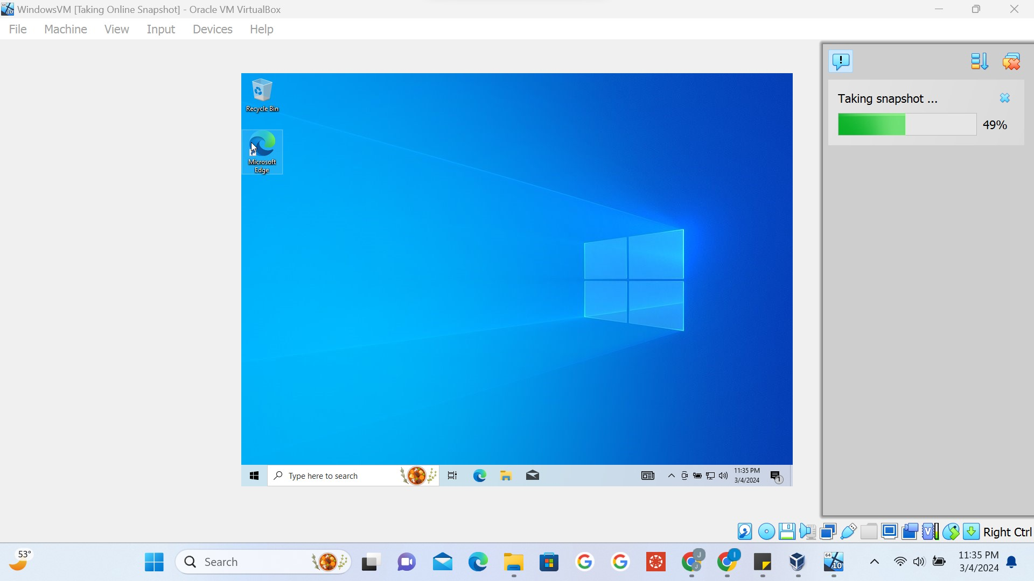

# purpose of taking a snapshot

Taking a snapshot in VirtualBox allows you to capture the current state of a virtual machine at a particular moment. This snapshot includes the VM's settings, memory, and disk state. By taking snapshots, you can create restore points that enable you to revert back to a previous state if something goes wrong during testing or experimentation. Snapshots also make it easier to create multiple configurations of a VM without having to recreate them from scratch each time. Overall, snapshots provide a convenient and efficient way to manage and protect your virtual machines.

**Task 4: Making Changes and Taking Another Snapshot**

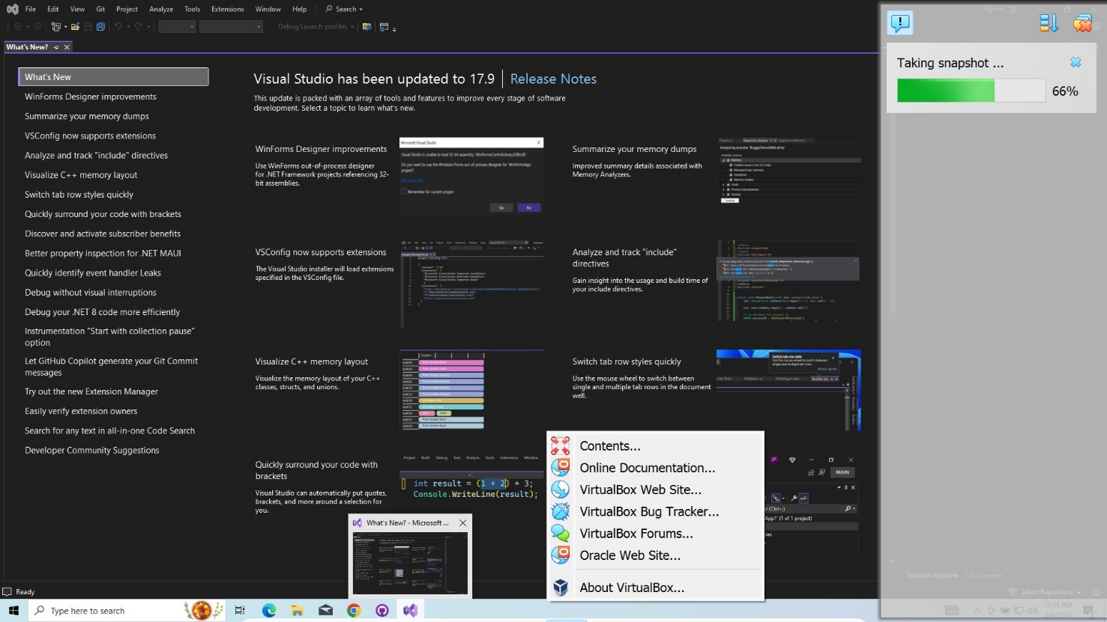

**why is it essential to take snapshots before making significant changes to a VM.**

Taking snapshots before making significant changes to a virtual machine is essential for several reasons. Firstly, snapshots serve as a form of backup, allowing users to revert to a previous state if the changes result in unexpected issues or errors. This capability is particularly valuable when experimenting with configurations, software installations, or system updates that could potentially destabilize the VM. Secondly, snapshots provide a safety net for testing purposes, enabling users to try out different configurations or software setups without fear of irreversible consequences. This flexibility encourages experimentation and innovation within the virtual environment.

**Task 5: Steps to Revert to a Snapshot - Demonstrate the process of reverting to one of the snapshots you created earlier.**

1. Click on Options of Virtual Machine you wanted to restore and select the Snapshot option from the list.

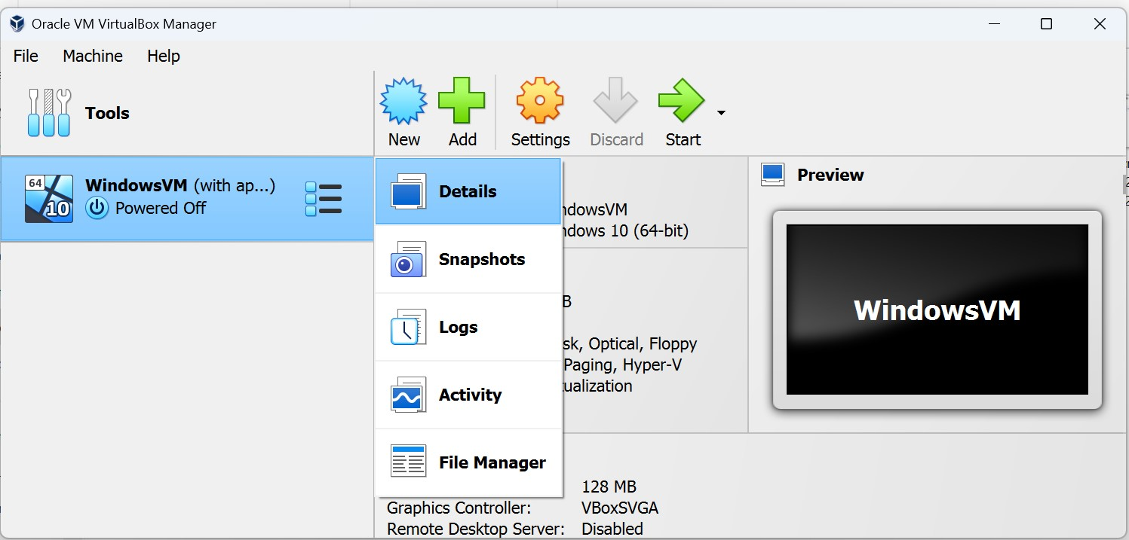

2 – Select the Snapshot you wanted to restore from the list of available snapshots as a tree.

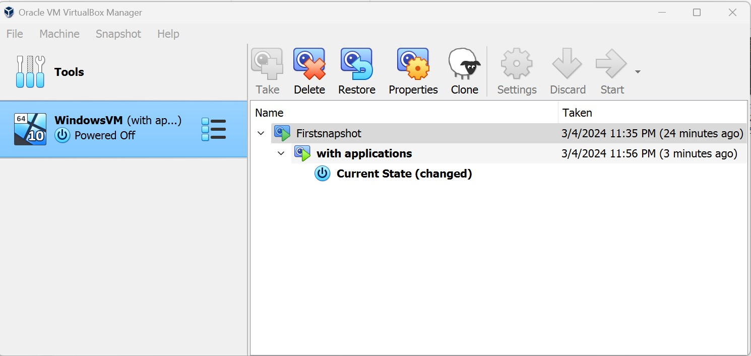

3 – click on Restore option from the menu above.

4 – on clicking on confirm VM will be restored to the selected snapshot.

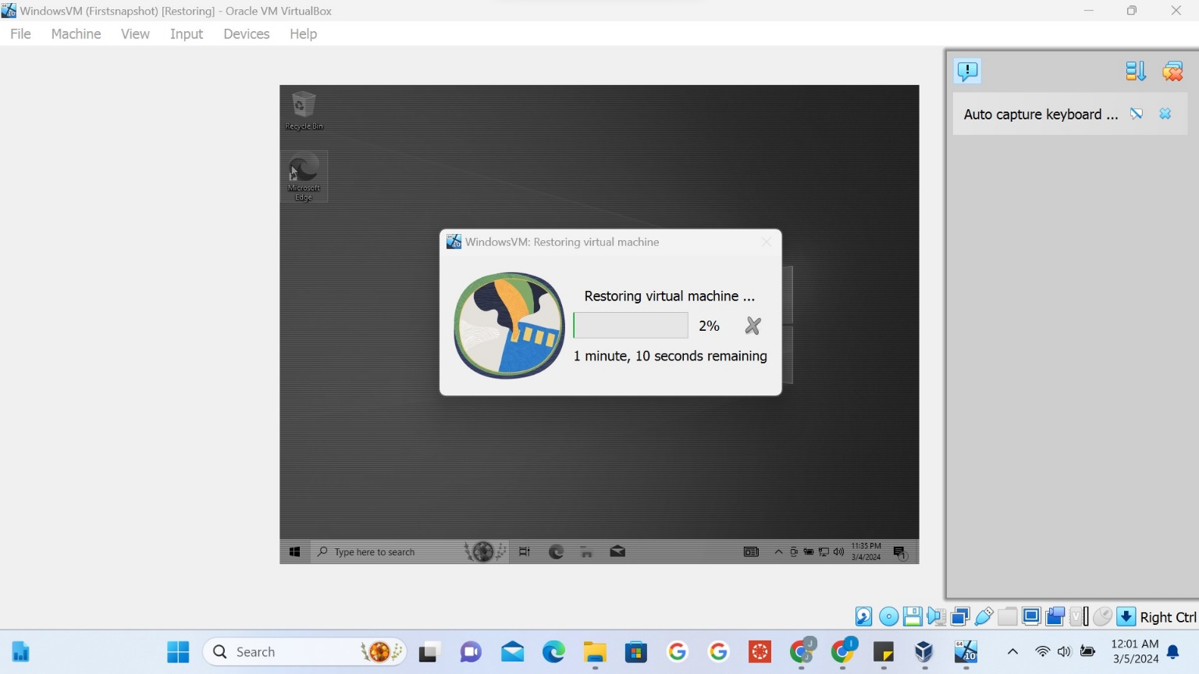

Task 6: Submission –

Creating a Windows VM in VirtualBox allows users to run Windows operating systems on their computers without needing a separate physical machine. Snapshots play a crucial role in this setup by providing a safety net for system changes and updates. Before making significant changes to the Windows VM, such as installing new software or updates, users can take a snapshot to capture the VM's current state. If the changes cause issues or if the user wants to revert to a previous configuration, they can easily restore the VM to the snapshot, effectively undoing any modifications. This process helps users avoid potential data loss, system instability, or other problems that may arise during experimentation or troubleshooting. Overall, snapshots provide a convenient and reliable method for managing and protecting Windows VMs in VirtualBox.